Public Consultation Briefing Note
- Introduction and Planning Policy Position
  - The site is 6.7 acres in size and is located off Nettleham Road/Juniper Drive, being in the ownership of Barber Farms Ltd. The site is allocated for residential development within the Central Lincolnshire Local Plan (ref: WL/SC/004A), for 41 dwellings. The site also forms an allocation (Site H1.5) in the currently emerging Scothern Neighbourhood Plan which has recently been approved for referendum. The Neighbourhood Plan establishes detailed design criteria for the site, within Policy H4.
  - As an allocated site, the principle of developing the site for residential development has been established in planning terms, subject to technical detail and design considerations to be determined through the planning process. This briefing note addresses a number of these issues, to specifically inform local residents on the proposals being brought forward and invite comments as part of this consultation.

- The Proposals
  - The site is proposed to be brought forward by Lindum Homes. Part of local construction company Lindum Group Ltd, Lindum Homes are a Lincoln based housebuilder who have been building quality homes in Lincolnshire for over 50 years. With our own local workforce, we take an extra pride in what we do and the locations within which we deliver housing – it matters to us, and we like to work with local communities to ensure we get it right.
  - We are proposing to deliver 49 units on this site, with 37 being market houses and 12 being affordable houses (a mix of rent, shared ownership and discounted market sale tenures). This ensures 25% of the total dwellings with be affordable and prioritised for local people, in accordance with Central Lincolnshire and Neighbourhood Plan Policy. Three of these affordable dwellings will also be bungalows, in accordance with the provisions of the Neighbourhood Plan which seeks to prioritise specialist housing for older people.
  - The other units are proposed to be two storey and a mix of 2, 3, 4 and 5 bed properties, and accessed off Nettleham Road only, with no vehicular through route to Juniper Drive. The units would be a mix of detached, semi-detached and terraced properties.

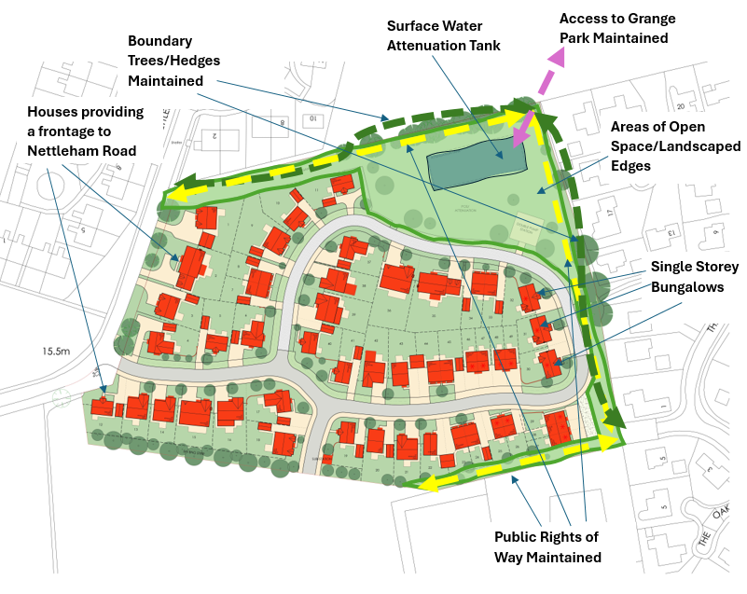
- Proposed Layout and House Designs – Key Features

  - The layout has specifically been informed by Policy H4 of the Neighbourhood Plan, and seeks to ensure:
- The Public Rights of Way to the east and south of the site are maintained and incorporated into an improved green corridor for existing and proposed residents;
- The access into Grange Park is maintained as part of the development;
- A 9m easement between the ditches to the north and east is incorporated, ensuring good degrees of separation to properties which back onto the site from Cade Close and The Alders;
- Boundary Trees, Hedgerows and vegetation is maintained to the north, south and east.
- The majority of the hedgerow to Nettleham Road is retained, whilst providing a frontage to this road to ensure a positive entrance into the site and into the village from Nettleham;
- Public Open Space is provided on site, together with landscaped strips around the site to ensure a ‘green’ edge is provided, reducing the impact of the built form of development;
  - The houses would be of traditional design and materials, reflecting the local vernacular the historic character of the village. Predominantly built in red or buff brick, the houses will include traditional features like chimneys and bay windows, as illustrated by the Greenwich/Regent/Richmond types shown below which will be included in the development.
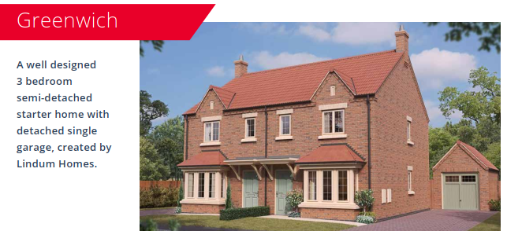

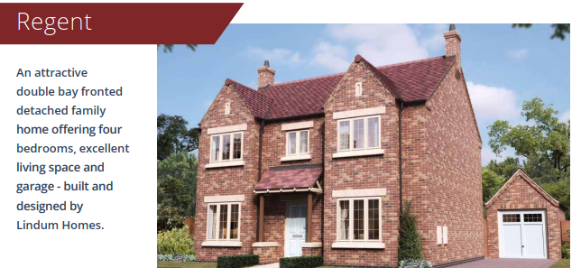

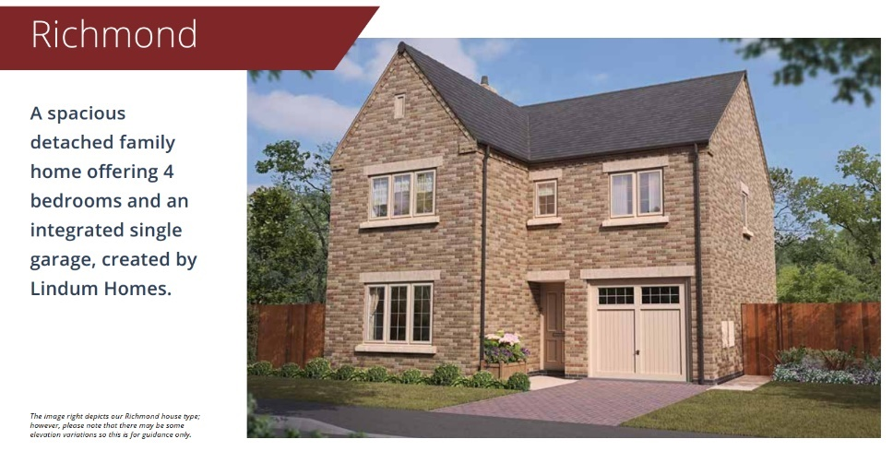

  - In addition, each property has on plot parking, with a minimum of 2 parking spaces per dwelling. This avoids the need for excessive amounts of on street parking and improves the look and feel of the development.
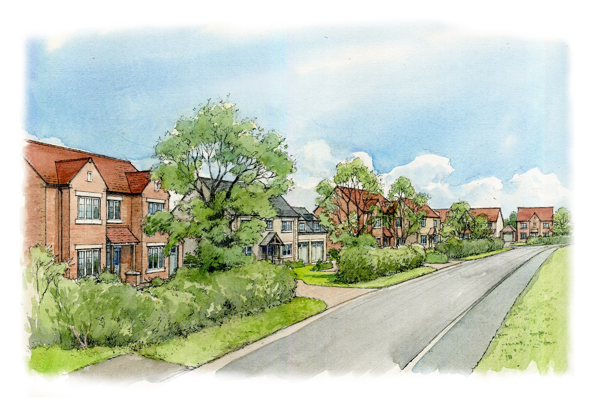
  - The site will also accommodate a large surface water attenuation tank, designed to hold water on site and ensure it only leaves once there is capacity in the local system. This is explained in more detail later in this briefing note.
Proposed view south out of the village, along Nettleham Road

- Density
  - The proposals are for 49 dwellings, which it is recognised exceeds the allocation numbers in the Central Lincolnshire Local Plan. It is important to note, however, that the Local Plan states at paras 13.2.3 and 13.2.4:
“The indicative numbers of dwellings are used to demonstrate how the Local Plan requirement can be met. It is emphasised that they are only ‘indicative’, and do not represent a fixed policy target for each individual site.
Developers are encouraged to produce the most appropriate design-led solution, taking all
relevant Local Plan policies and national policy into account, in arriving at a total dwelling
figure for their site, and they need not be constrained by the figure that appears in the
column headed ‘indicative dwelling figure”.
  - As demonstrated above, the layout proposed incorporates the design considerations articulated in the Neighbourhood Plan through the retention of public rights of way and green corridors, whilst also providing a significant level of surface water attenuation (explained more below).
  - As such, even at 49 dwellings, the proposals remain some way below our usual densities, and it is felt that the proposals provide a quality development which responds to the constraints of the site and the character of the village.
- Technical Considerations
Flood Risk and Drainage
  - Environment Agency Flood Mapping confirms that the site is located in Flood Zone 1, which means the site has a very low likelihood of flooding. Whilst it is noted that areas of the site do hold water from time to time, this is predominantly due to the topography of the site, with water collecting in the lower lying areas.
  - The topography of the site directly influences the drainage solutions proposed for the site. In the first instance, the current field drains predominantly to the north and east into the existing network of ditches surrounding the site. These ditches flow northwards, towards the centre of the village where we are aware there have been significant problems in the recent past.
  - Our proposals, however, have sought to avoid directing the sites surface water into these ditches in the hope we can improve the existing situation. Instead, the proposals would be pumped southeast, to the existing Anglian Water sewer in The Alders. Anglian Water have confirmed that the sewer has capacity to receive these flows. This water then goes south out of and away from the village, through the existing Anglian Water network towards Sudbrooke.
  - Importantly, however, the proposals also include a large, underground attenuation tank. Built to Anglian Water specification and adopted by them, this is specifically designed to hold water during peak rainfall events. At such times, water is held in this tank and only released into the receiving system at a rate which ensures it is never overwhelmed and has the capacity to receive it.
  - This engineered system has therefore been specifically designed to ensure that the sites surface water is dealt with on the site itself, and only leaves the site at a rate which safeguards the existing system to make sure it is not compromised. Importantly, it is hoped that this system actually improves the existing situation, which currently sees water running unrestricted into the surrounding ditches and towards the centre of the village.
  - In terms of foul drainage, this will be directed to the northwest and into existing sewer on Nettleham Road. Once again, Anglian Water have confirmed there is capacity within the system to receive foul flows from the site.
Ecology and Biodiversity
  - No evidence of protected species utilising the site has currently been found. The site is, however, suitable for foraging bats and foraging badgers. Further assessments will be required in relation to these species, whilst the new dwellings will incorporate both bird and bat boxes.
  - The development is also required to deliver a 10% net gain in Biodiversity, either on or off site. We will endeavour to do this on site where we can, with new trees and landscaping in the large areas of new spaces provided on site - this is likely to include new wildflower area and insect/hedgehog refuges.
Sustainability and Climate Change
  - The houses will be designed to achieve net zero in terms of carbon emissions and consumption. This means that they will be designed to the highest levels of energy efficiency, with increased insultation and triple glazed windows to reduce heat loss.
  - As well as this, the site will not be connected to the gas network, and the houses will instead utilise air sourced heat pumps and solar panels to generate energy from renewable sources to meet the requirements of the households.
  - Each house will also come with an electric car charging point, and all of these measures are designed to ensure that any electricity taken from the grid is replaced via energy generated on each plot.
Transport and Highways
  - The transport impact of the scheme has been assessed via a Transport Statement, the scope of which has been agreed with Lincolnshire County Council (LCC) as Highway Authority. Firstly, vehicular access to the proposed development will be provided via Nettleham Road to the west of the site via a new simple priority T-junction connecting with Nettleham Road on the eastern site boundary. The new junction exceeds LCC’s visibility standards.
  - The vehicle and person trip generation of the proposed development has been projected using the industry standard TRICS database. The proposals are expected to generate a maximum of 28 two-way vehicle trips during the AM peak hour (08:00-09:00) and 29 during the PM peak hour (17:00-18:00). This equates to, at worst and on average, less than 2 cars accessing and leaving the site every minute.
  - Based on this frequency of movement, it is considered that the proposed residential development would not have any discernible impact on the operation of the local highway network.
  - In terms of parking, this will be provided on plot with all properties having a minimum of two spaces, with the larger properties having more than this. We are also looking at the provision of dedicated visitor parking spaces, although these are not currently shown on the layout.
- Impact on Local Services
  - Any future planning application would be assessed by the statutory authorities, including the NHS as the Health Authority and the County Council as Education Authority. These authorities will assess the impact on local primary schools and doctors surgeries, and if required will request financial contributions to improve these services.
  - The site will, if granted planning permission, financially contribute to the improvement of local secondary school provision, through the Community Infrastructure Levy which is already in place and paid to West Lindsey District Council.
  - In terms of play space provision, large areas of open space are proposed on site which could be utilised as play provision. on site given the proximity of the existing provision directly opposite the proposed development. Alternatively, we could look to improve existing provision locally, for instance in Grange Park, and we would welcome your views on this.
- Conclusions and Next Steps
  - This briefing note summarises many of the key issues in relation to the proposed development. The reports which provide much more detail on these matters are available on our website www.lindumgroup.com/scothern-homes-consultation
  - We would very much welcome your feedback on these proposals, which should be sent via email to planning@lindumgroup.co.uk. Please state within your feedback if:
- You support these proposals (and why) or;
- You support these proposals, but have concerns (and if so, what these may be) or;
- If you do not support these proposals (and why).
  - The consultation runs until 17th May 2024 and all feedback will be reviewed, considered and addressed as far as practicable when the planning application is made in summer 2024.

